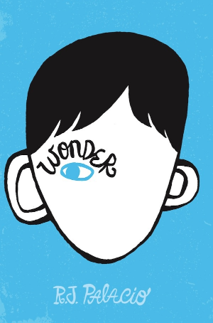
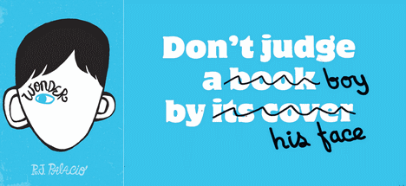
January 2018

Sun | Mon | Tue | Wed | Thu | Fri | Sat
 | 1 X | 2 | 3 | 4 | 5 | 6X
7X  South Lewis Middle School  One School, One Book | 8 Auditorium Kick-off  Part 1: August  Read pgs. 4-14 | 9  Read pgs. 15-23 | 10  Read pgs. 24-34 | 11  Read pgs. 35-44 | 12  Read pgs. 45-60 | 13X
14X | 15X | 16  Read pgs. 61-70 | 17  Read pgs. 71-80 | 18 Part 2:Via  Read pgs. 82-90 | 19  Read pgs. 91-106 | 20X
21X | 22  Read pgs.  107-117 | 23  Part 3: Summer  Read pgs. 118-123 | 24  Read pgs.  124-132 | 25  Part 4: Jack  Read pgs. 133-145 | 26  Read pgs.  146-157 | 27X
28X | 29  Read pgs.  158-169 | 30  Read pgs.  170-185 | 31  Part 5: Justin  Read pgs. 186-195
February 2018

Sun | Mon | Tue | Wed | Thu | Fri | Sat
 |  |  |  | 1  Read pgs.  196-204 | 2  Part 6: August  Read pgs. 205-216 | 3X
4X  South Lewis Middle School  One School, One Book | 5  Read pgs.  217-227 | 6  Read pgs.  228-234 | 7  Part 7: Miranda  Read pgs. 235-248 | 8  Part 8: August  Read pgs. 249-256 | 9  Read pgs.  257-272 | 10X
11X | 12  Read pgs.  273-280 | 13  Read pgs.  281-288 | 14  Read pgs.  289-297 | 15  Read pgs.  298-310 | 16  Finish book over break if not done by now | 17X
18X | 19 X | 20 X | 21 X | 22 X | 23 X | 24X
25X | 26 | 27 | 28 | 1 | 2  Ending Celebration

